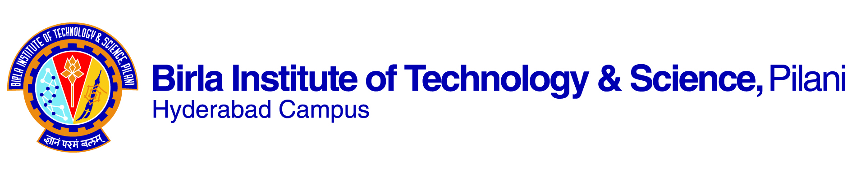

**SECOND SEMESTER 2019-2020**

# Course Handout Part II

Date: 06-01-2020

In addition to part-I (General Handout for all courses appended to the time table) this portion gives further specific details regarding the course.

*Course No.* : BITS F399

## Course Title : Humanistic Theories of Science and Technology

## Instructor-in-Charge : Aswathy Raveendran

**Scope and Objective of the Course:**

Ways of considering the interrelationship among three of the major dimensions of our culture: its science, its technology and its humanistic orientation. Alternative ways of thinking about science and technology, diverse approaches of humanistic scholarship to studying science and technology, along with their historical sources. Approaches by social scientists to analyze technical fields of science and technology

**Textbooks:**

1. Sismondo, Sergio. 2004. *An introduction to Science and Technology Studies*. UK: Blackwell Publishing.

**Reference material**

1. Kitcher, P. (2003). Science, truth, and democracy. Oxford University Press
2. Allchin, D. (1999). Values in science: An educational perspective. *Science & Education*, 8(1), 1-12.
3. Achuthan, A. (2011). Re:wiring bodies. Bangalore: The Centre for Internet & Society.
4. Sur,A. (2011). Dispersed radiance: Caste, gender, and modern science in India. New Delhi: Navayana.

**Course Plan:**

|  |  |  |  |
| --- | --- | --- | --- |
| **Lecture No.** | **Learning objectives** | **Topics to be covered** | **Chapter in the textbook** |
| 1-8 | To appraise the field of Science-Technology-Society studies, it’s key concerns and approaches. | Interactions between science, technology and society; ethical and political issues | RM 1: Chapter 1 |
| 9- 18 | To reflect on the nature of science, and how philosophers and sociologists evaluate the nature of scientific knowledge. | Science and pseudoscience; science and alternative knowledge systems; debates on rationality and methods; values and science | TB chapter 1,3, 5, 6 and RM 2 |
| 20- 28 | To understand the nature of technology | What is technology? The relationship between technology, science and society | TB chapter 9 |
| 28-32 | To explore the debates related to the public understanding of science | Public understanding of science, debates on science and technology in contemporary India | RM 3, TB chapter 15 |
| 33-41 | To analyze the gender and minority question in science and technology | Gender, caste and race in science and technology- key issues | TB chapter 7, RM 4 |

NOTE: In addition to or instead of the textbook and reference material mentioned above, based on perceived need, students may be required to go through reference material made available at various stages of the course.

**Evaluation Scheme:**

|  |  |  |  |  |
| --- | --- | --- | --- | --- |
| **Component** | **Duration** | **Weightage (%)** | **Date & Time** | **Nature of Component** |
| Mid-semester exam | 1.5 hours | 30 | 4/3 9.00 - 10.30AM | Closed book |
| Assignment 1 and 2 | - | 30 | To be announced | Open book |
| Comprehensive exam | 3 hours | 40 | 06/05 AN | Closed book |

**Chamber Consultation Hour:** will be announced in the class

**Notices:** will be put up on CMS

**Make-up Policy:** Make ups will be granted only for exceptionally deserving cases.

**Academic Honesty and Integrity Policy:** Academic honesty and integrity are to be maintained by all the students throughout the semester and no type of academic dishonesty is acceptable.

Aswathy Raveendran

**INSTRUCTOR-IN-CHARGE**